**Exercise 1: Implementing the Singleton Pattern**

**Solution:**

Logger Class:

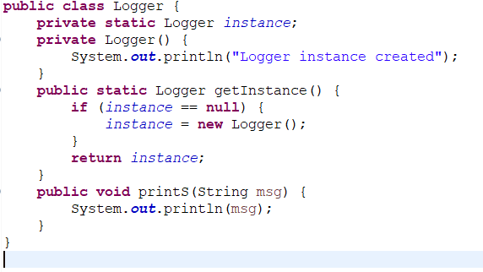

Test Class:

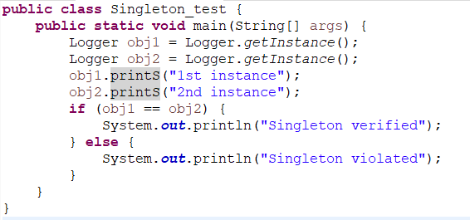

Output:

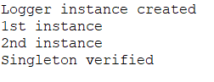

**Exercise 2: Implementing the Factory Method Pattern**

**Solution:**

Document Classes:

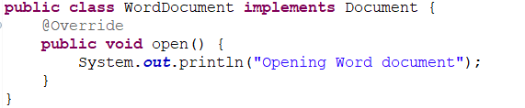

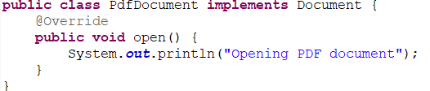

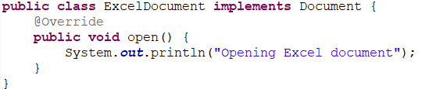



Concrete Factory Classes:



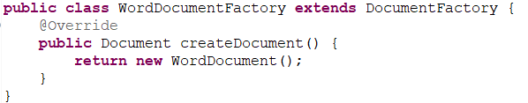

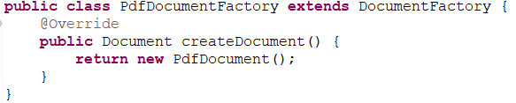

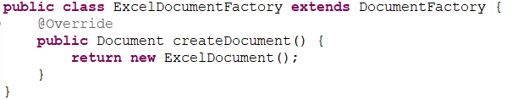

Test Class:

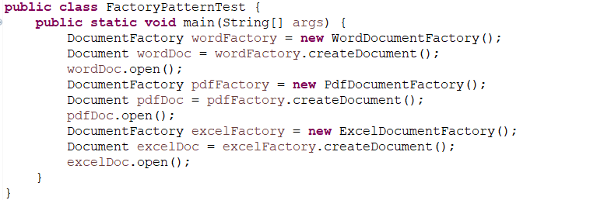

OUTPUT:

